Information for parent/carers
Spend time playing with your children
Why is play important?
Playing isn’t just fun – it is the best way for young children to learn. By playing, children can practise all the skills they will need as they grow up.
Make time to join in your child’s play, follow their lead. Introduce children to new vocabulary as you talk about what you are doing. Make sure you listen carefully to your child. If you ask them a question, give them some time to think, count to 5 in your head.
Try some of these:
- Have a tea party – invite the toys and teddies and other willing people in your house.
Count how many cups and plates you need. For those learning Welsh, try naming some of the foods in Welsh. You could make food out of playdough. Role-model appropriate language.
- Be a pirate – make a costume, draw a map and follow it to find the treasure
- Set up a shop – take turns to buy items and pay for it with real coins
- Play with Lego (or a similar construction kit) -build a village and use toy cars/small world people and animals to play in it, build vehicles or robots. Need some inspiration? Try the following website:
https://frugalfun4boys.com/simple-projects-beginning-lego-builders/
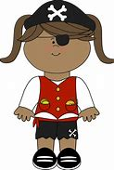
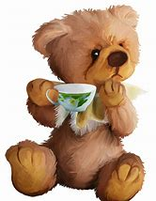
https://frugalfun4boys.com/lego-party-games/
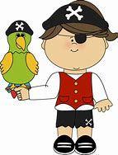

Encourage them to join in with everyday jobs and tasks
Let them help you with the washing, washing dishes and preparing meals. Not only will this equip them with important life skills, develop their understanding of mathematics in real life, mathematical language and communication skills but you will get your jobs done too. Make it fun and they will be happy to join in. Let them match the socks, make biscuits, cakes or fruit kebabs. Why not get your bikes out for an MOT
Cooking with young children –
Cooking is full of mathematics, talk to your child about weighing, let them count out the required tablespoons, talk about the difference between the sizes of the spoons, discuss cutting foods into different number of pieces, time how long food needs to cook
Cooking can help develop fine motor skills – let the children peel, mix, whisk and chop. As long as children are supervised, they are capable of doing these tasks.
Healthy eating and learning about food – this is a perfect time to discuss how and where food comes from and the importance of eating a balanced meal.
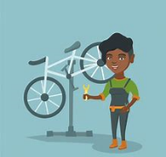
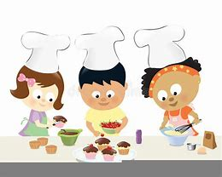
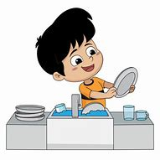

For some simple recipes take a look at:
https://www.bbc.co.uk/food/collections/10_easy_recipes_for_kids
https://www.sitters.co.uk/blog/15-fun-cooking-activities-for-kids.aspx

Fine motor skills
Let them help you peg out the washing. Using pegs will strengthen the muscles in their hands and prepare them for writing later.
Playdough – rolling, squashing, stretching and squeezing playdough all help develop those muscles. Not sure how to extend the play? Or want to know how to make your own playdough? Have a look at the following websites
https://artsymomma.com/playdough-activities-guide.ht
https://abcdoes.com/abc-does-a-blog/2010/08/21/playdough-recipes/
Or why not go to a dough disco – watch and join in with songs on Spread the Happiness TV on youtube
https://www.youtube.com/watch?v=KSBO8N4ctJg&list=PLtw-7Jf06an0-84tDAgicwfYUqBD9Qfkm
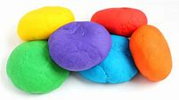
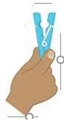

Reading
Fostering a love of story and sharing of books play a significant role in developing reading
- Read at least two stories a day- five a day if you can manage it!
- Repeat favourite stories often. You may get bored, but children will love the repetition, it will help them become more confident with the structure and the language
- Encourage children to join in, turn pages, comment on the pictures
- Ask questions about the story e.g. What do you think will happen next? What was your favourite part of the story/ character? Why do you think the character did…?
- Play matching games for example, hat and ? (cat)
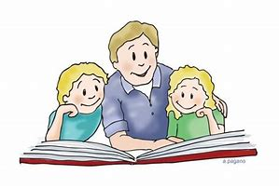

Learning nursery rhymes and songs is very important too. The following websites have a wide variety of rhymes and stories for you to learn and sing or listen to together.
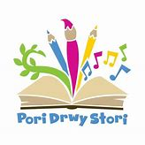

Pori Drwy Stori

https://www.booktrust.org.uk/what-we-do/programmes-and-campaigns/poridrwystori/nursery/

Welsh Nursery Rhymes – Hwiangerddi

http://welshnurseryrhymes.wales/Gartref

Caru Canu

https://cyw.cymru/en/caru-canu/

Play games
Games, board games and card games will develop children’s
- mathematical development – recognising numbers on the dice, matching in pairs games, counting as they move a counter
- language skills – communicating with others as they play, following instructions
- personal and social development - learn to take turns, learn to cope with disappointment and build resilience if they do not win!
Quick simple games to play:
- I spy – something green and when your child is ready – something beginning with a (use letter sounds rather than letter names so a as in ant rather than ay as in ape)
- Kim’s game - Put 5 things from around the house on a tray - it could be things like a pencil, an orange, some cotton wool, a toy etc. Ask your child to look carefully at them for about thirty seconds. Then take the tray away and ask them to call out what they remember.
Another way of playing the game is to cover the things, take one thing away and ask the child to spot what is missing. You can put more things on the tray as they get better
- Simon says
- Complete a jigsaw puzzle
Outdoor games are very important too. Children need exercise and to burn off some energy:
- Follow my leader – make sure you include actions such as jogging, star jumps, kicks etc
- Tag – an old favourite to get you moving
- Hopscotch – another old favourite, draw the grid with chalk – the bigger you make it the further they will have to hop and jump
- Pop the bubbles – you can make solution with washing up liquid and water. Or use a balloon and stop it from touching the ground for as long as you can
- Make an obstacle course out of anything you can find – who can complete it the fastest?
- Go on a scavenger hunt – draw or print 5 items that your child has to find

Mindfulness and Keeping Active
We are living in unprecedented, uncertain times. Some children and parents may be feeling anxious and worried. Keeping active and introducing some mindfulness could help.

Smiling mind
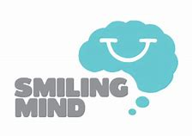
Free mindfulness meditation app helping to look after our minds and mental health.

Cosmic Kids Yoga
https://www.youtube.com/user/CosmicKidsYoga
Yoga, mindfulness and relaxation designed specifically for children aged 3+
Be Creative
Being creative allows children to develop mentally, socially and emotionally – as well as developing essential basic skills. As young children manipulate a paintbrush, their fine motor skills improve. By counting pieces and colours, they learn the basic maths skills. When children experiment with materials, they dabble in science. Children who feel able to experiment and to make mistakes feel free to invent new ways of thinking, which is an essential skill that we need for our future. Let children enjoy the process rather than ask them what they are painting or making (they might not have thought about it). Allow them to be in the moment and paint or create without an end goal in mind.

Tip and ideas to promote creativity:
- Be prepared for a mess – lay down a plastic sheet or newspaper, put an oversized t-shirt or shirt on your child to protect clothing. Encourage your child to help tidy up at the end
- Collect natural materials from the garden or local part and use them to create a picture or collage
- Use old cardboard boxes to paint on – the bigger the better!
- Allow your child to use old magazine to cut and stick – combine these with other materials and painting or drawing

Websites
Here are some useful websites full of activity ideas for you to play with your child
CBeebies Radio
https://www.bbc.co.uk/cbeebies/radio
Listening activities for younger children
Nature Detectives
https://naturedetectives.woodlandtrust.org.uk/naturedetectives/activities/
A lot can be done in the garden if you are unable to go anywhere else!

The Imagination Tree
https://theimaginationtree.com/
Creative play and learning for young children

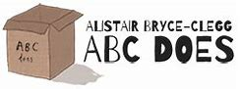
ABC does – 50 Fantastic ideas to try at home
https://abcdoes.com/home-learning/
At least 50 play-based activities to do at home with items that you will find in the house

Spread the Happiness
https://www.spreadthehappiness.co.uk/product/100-things-to-do-indoors/
Free resource – 100 things to do indoors

https://hungrylittleminds.campaign.gov.uk/
Activities and games for under 5s

Online Games and Apps
The best way to use these games and apps is to sit with your child while they are online. Children learn a great deal from listening to an adult narrating what is happening and thinking out loud. Model how you work an answer out, for example ‘The bear has 3 cakes now so I think the bear will have 4 cakes, when I add one more because I know that 4 comes after 3’. Use the opportunity to encourage children to explain their thinking too ‘Why do you think that?’ or ‘how did you work that out?’

Topmarks https://www.topmarks.co.uk/maths-games/3-5-years/counting

Crickweb http://www.crickweb.co.uk/Early-Years.html

Bys a Bawd - App for Welsh songs

Byd Cyw - App with games and songs from Cyw

Nature Passport - App with lots of ideas for you to do in the outdoors

Caneuon Selog
Straeon Selog - App for Welsh songs and stories

Dewin a Doti - App Welsh stories for young children

